Dominic Drury

09/12/2024

CS-470

2-2 Assignment: Docker Containerization

Docker images command output

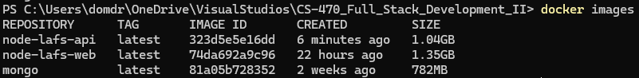

Angular frontend running in the container, showing the URL on the local host

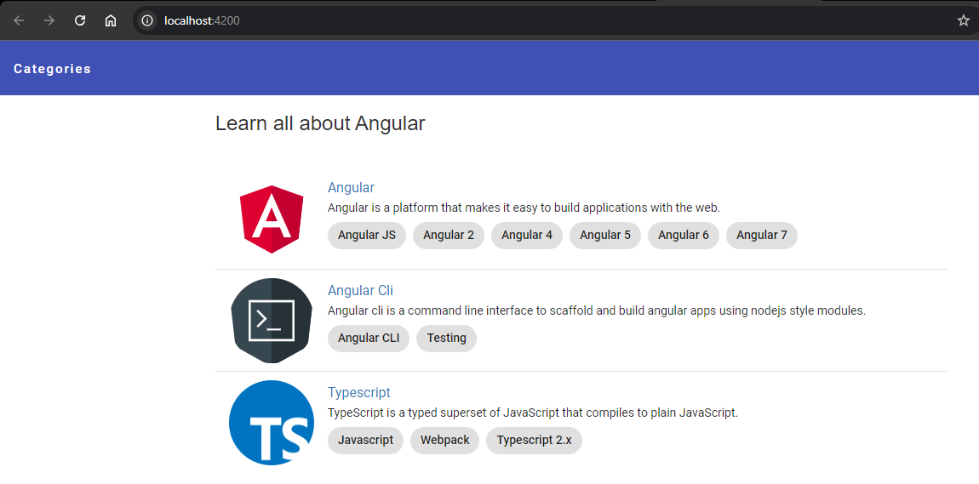

LoopBack API Explorer frontend running in the container, showing the URL on the local host

